**UPS INSTRUCTIONS**

|  |
| --- |
| **Log In** |
| Login to UPS Account [UPS Campus Ship](https://www.campusship.ups.com/login?reasonCode=-1)   * + If you don’t have a UPS account with Merck, reach out to Elinor Brooks to create one |

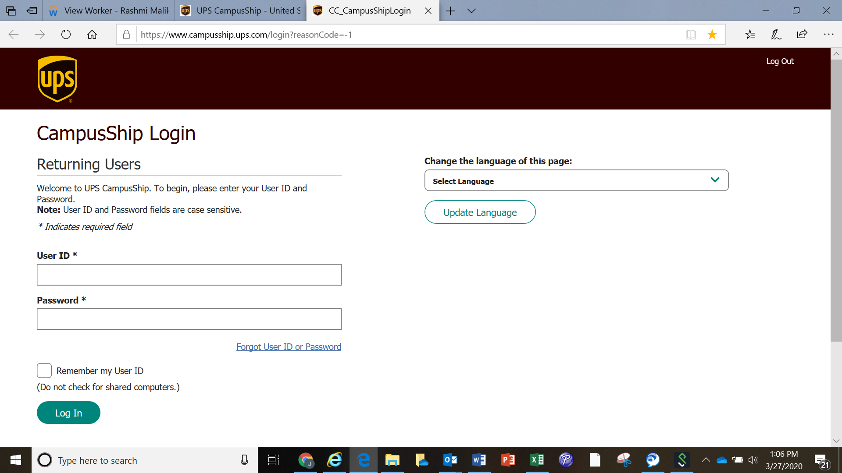

|  |
| --- |
| **Create a Return Label** |
| * + Once again, you will need a UPS account. If you don’t have one, please contact Elinor Brooks. |
|  |
|  |

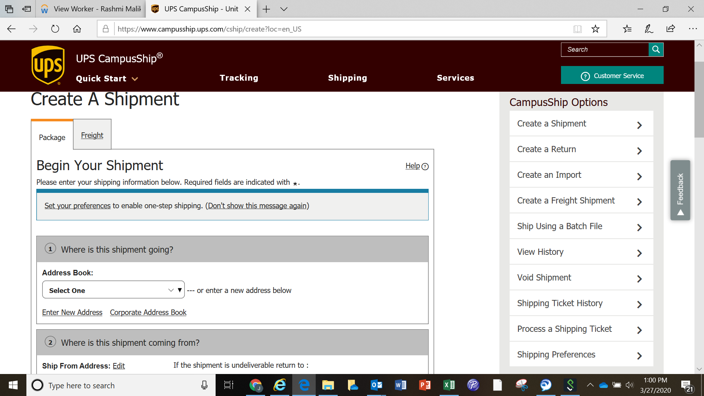

|  |
| --- |
| **How To Enter Return Information** |
| The steps below will help you complete the Create a Return process.   1. **Return From Address Information:** Select a Return From address (e.g., the original recipient address) from the drop-down list or an external address book (if available). Or, select **Enter New Address**. THIS IS THE EMPLOYEE’s HOME ADDRESS (please also include the Employee’s home/cell phone and personal email address). 2. **Return To Address Information:** After the page refreshes, confirm the Return To Address information. To make any changes, select **Edit**. THIS IS THE MANAGER/ADMINISTRATIVE ASSOCIATE’s MERCK OFFICE ADDRESS 3. **What are you Returning:**    * **What are you returning?** If American Express and Company ID only, SELECT UPS LETTER. If additional Merck property is being returned, please select appropriate selection, such as Small, Medium, or Large Box.    * **Weight?** Estimate Weight. For returns of Amex and Company ID only, you can enter 1 lb. For other items, put on scale if you have one or estimate).    * **Estimated Value?** 0    * **Merchandise Description?** Business Documents 4. **How would you like to Return:**     * Select the Return Service you want to use from the drop-down list – SELECT 2nd Day Air.    * **Label Delivery Method?** SEE BELOW DEFINITIONS. If your employee has access to a printer, SELECT ELECTRONIC RETURN LABEL. If not, please choose another option.    * **Send Email Notifications?** CLICK (Free)   Label Delivery Method DEFINITIONS: UPS provides various return services that allow you and your package recipients to return goods by paying a nominal fee. Select the Return Service you want to use from the drop-down list. When selecting a return service you have the option of billing yourself, the person or company returning the package, or a third party.  **UPS ReturnsSM - Electronic Return Label (ERL) E-mail** With this Return Service, UPS sends a return label via e-mail to the recipient you specify. The recipient prints the return label and attaches it to the package being returned. IF YOUR EMPLOYEE HAS ACCESS TO A PRINTER, SELECT THIS OPTION. Be sure to put their personal email address as the recipient. Employee can print from home. If the employee doesn’t have access to a printer, please select another option below.  **UPS Returns - Print Return Label** This Return Service allows you to create a return label and send it to the recipient with your shipment or separately.  **UPS Returns - Print and Mail Return Label** With this Return Service, UPS prints your return label and mails it to the party making the return. **UPS Returns Plus** With this option, a UPS driver carries a preprinted return label when attempting to pick up the return package.   * **1 UPS Pickup Attempt** allows the shipper to request one pickup attempt for return of a UPS-compatible package. If the package cannot be picked up, the label is left for the recipient to return the package via any UPS method. * **3 UPS Pickup Attempts** allows the shipper to request three pickup attempts for return of a UPS-compatible package. After the third pickup attempt, the label is returned to UPS.   **ALTERNATE OPTION:** If the above options do not work, you (manager) can select PRINT Label. When the label appears, do the following:   * Right Click on Label – SELECT ALL * Right Click Again on Label – SAVE AS * Save document (it will be a .PNG) * THEN email this document as an attachment to your employee. He/she can print at home.  1. **Would you like to add a reference number to this shipment:** COST CENTER IS REQUIRED (please put your department cost center in this field). Reference number is not applicable, unless you want to include. **Reference Number Information:** A shipment reference may be added to any shipment for ease of tracking or allocating costs. Shipment references can be any combination of letters and numbers up to 35 characters. **Reference #1** can be selected to print as a bar code on the shipping label. This option applies to all packages in the shipment. Your UPS CampusShip Administrator may assign specific value types for your company (e.g., Charge Back Code, Client Account Number, Purchase Order Number). Administrators may also set preferences to require or validate the Reference Number fields. 2. **How would you like to pay:** Confirm the Bill Shipping Charges To information, which displays your default payment method (should already be filled out with your Merck account details). To make any changes, select **Edit**. |
|  |
| **UPS PICK UP** |
| Employee will need to contact UPS to arrange at home pick up. If employee does not have UPS envelope or box, they will need to let UPS know that they need supplies upon pick up. |
|  |
|  |